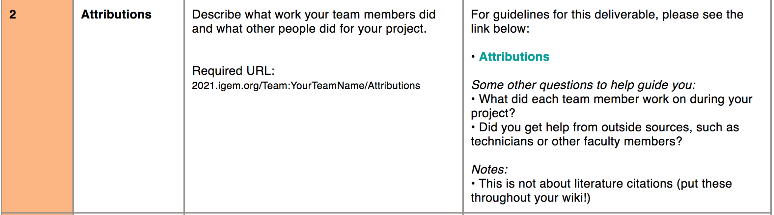

**Example**: <https://2020.igem.org/Team:SDU-Denmark/Attributions>

# **Attributions**

Use this page to attribute work done on your project. This includes the work done by each of the student members on your team and any work that was done by people outside of your team, including the host labs, advisors, instructors, and individuals not on the team roster. This requirement is not about literature references - these can and should be displayed throughout your wiki.

### **Bronze Medal Criterion #2**

Describe what work your team members did and what other people did for your project

Please see the [**Medals requirements page**](https://2021.igem.org/Judging/Medals) for more details.

### **What should this page contain?**

* Clearly state what the team accomplished
* General Support
* Project support and advice
* Fundraising help and advice
* Lab support
* Difficult technique support
* Project advisor support
* Wiki support
* Presentation coaching
* Human Practices support
* Thanks and acknowledgements for all other people involved in helping make a successful iGEM team

Tell us if your institution teaches an iGEM or synthetic biology class and when you started your project:

* Does your institution teach an iGEM or synthetic biology course?
* When did you start this course?
* Are the syllabus and course materials freely available online?
* When did you start your brainstorming?
* When did you start in the lab?
* When did you start working on your project?

### **Inspiration**

Take a look at what other teams have done:

* [**2019 William and Mary**](https://2019.igem.org/Team:William_and_Mary/Attributions)
* [**2019 Thessaloniki**](https://2019.igem.org/Team:Thessaloniki/Attributions)
* [**2019 Sydney Australia**](https://2019.igem.org/Team:Sydney_Australia/Attributions)
* [**2020 AUC EGYPT**](https://2020.igem.org/Team:AUC-EGYPT/Attributions)
* [**2020 Korea SIS**](https://2020.igem.org/Team:Korea-SIS/Attributions)
* [**2020 Manchester**](https://2020.igem.org/Team:Manchester/Attributions)
* [**2020 NJTech China**](https://2020.igem.org/Team:NJTech_China/Attributions)

### **Why is this page needed?**

The Attribution requirement helps the judges know what you did yourselves and what you had help with. You can get help with difficult or complex techniques, but you must report what work your team did and what work was done by others.

For example, you might choose to work with an animal model during your project. Working with animals requires getting a license and applying far in advance to conduct certain experiments in many countries. This is difficult to achieve during the course of a summer, but much easier if you can work with a postdoc or PI who has the right licenses.

### **Can we base our project on a previous one?**

Yes! You can have a project based on a previous team, or based on someone else's idea, **as long as you state this fact very clearly and give credit for the original project.**

Reisch

Donnelly

Get headshots of girls from Denmark

**Original code**

{{IGEM_TopBar}}

{{UFlorida}}

<html>

<div class="column full_size judges-will-not-evaluate">

<h3>★ ALERT! </h3>

<p>This page is used by the judges to evaluate your team for the <a href="https://2021.igem.org/Judging/Medals">medal criterion</a> or <a href="https://2021.igem.org/Judging/Awards"> award listed below</a>. </p>

<p> Delete this box in order to be evaluated for this medal criterion and/or award. See more information at <a href="https://2021.igem.org/Judging/Pages_for_Awards"> Instructions for Pages for awards</a>.</p>

</div>

<div class="clear"></div>

<div class="column full_size">

<h1>Attributions</h1>

<p>Use this page to attribute work done on your project. This includes the work done by each of the student members on your team and any work that was done by people outside of your team, including the host labs, advisors, instructors, and individuals not on the team roster. This requirement is not about literature references - these can and should be displayed throughout your wiki.

</p>

<h3> Bronze Medal Criterion #2</h3>

<p>Describe what work your team members did and what other people did for your project.

<br><br>

<br><br>

Please see the <a href="https://2021.igem.org/Judging/Medals">Medals requirements page</a> for more details.</p>

</div>

<div class="clear extra_space"></div>

<div class="column third_size">

<h3> What should this page contain?</h3>

<ul>

<li>Clearly state what the team accomplished</li>

<li>General Support</li>

<li>Project support and advice</li>

<li>Fundraising help and advice</li>

<li>Lab support</li>

<li>Difficult technique support</li>

<li>Project advisor support</li>

<li>Wiki support</li>

<li>Presentation coaching</li>

<li>Human Practices support</li>

<li> Thanks and acknowledgements for all other people involved in helping make a successful iGEM team</li>

</ul>

</div>

<div class="column third_size">

<p>Tell us if your institution teaches an iGEM or synthetic biology class and when you started your project:</p>

<ul>

<li>Does your institution teach an iGEM or synthetic biology course?</li>

<li>When did you start this course?</li>

<li>Are the syllabus and course materials freely available online?</li>

<li>When did you start your brainstorming?</li>

<li>When did you start in the lab?</li>

<li>When did you start working on your project?</li>

</ul>

</div>

<div class="column third_size">

<div class="highlight decoration_A_full">

<h3>Inspiration</h3>

<p>Take a look at what other teams have done:</p>

<ul>

<li><a href="https://2019.igem.org/Team:William_and_Mary/Attributions">2019 William and Mary</a></li>

<li><a href="https://2019.igem.org/Team:Thessaloniki/Attributions">2019 Thessaloniki </a></li>

<li><a href="https://2019.igem.org/Team:Sydney_Australia/Attributions">2019 Sydney Australia </a></li>

<li><a href="https://2020.igem.org/Team:AUC-EGYPT/Attributions">2020 AUC EGYPT</a></li>

<li><a href="https://2020.igem.org/Team:Korea-SIS/Attributions">2020 Korea SIS</a></li>

<li><a href="https://2020.igem.org/Team:Manchester/Attributions">2020 Manchester</a></li>

<li><a href="https://2020.igem.org/Team:NJTech_China/Attributions">2020 NJTech China</a></li>

</ul>

</div>

</div>

<div class="clear extra_space"></div>

<div class="column two_thirds_size">

<h3> Why is this page needed? </h3>

<p>The Attribution requirement helps the judges know what you did yourselves and what you had help with. You can get help with difficult or complex techniques, but you must report what work your team did and what work was done by others.</p>

<p>

For example, you might choose to work with an animal model during your project. Working with animals requires getting a license and applying far in advance to conduct certain experiments in many countries. This is difficult to achieve during the course of a summer, but much easier if you can work with a postdoc or PI who has the right licenses.</p>

</div>

<div class="column third_size">

<div class="highlight decoration_B_full">

<h3> Can we base our project on a previous one? </h3>

<p>Yes! You can have a project based on a previous team, or based on someone else's idea, <b>as long as you state this fact very clearly and give credit for the original project.</b> </p>

</div>

</div>

</html>